Objective 1: Describe the Dark Ages
  - How geography influenced life in Medieval Europe.
  - The impact of the Fall of Rome on Europe.
  - How feudalism shaped medieval society and what feudal life was like for nobles and peasants.

Vocabulary and People:
- Charlemagne: A Christian emperor who ruled many parts of Europe from 768-814. His rule was the closest that Europe came to unity in the Dark Ages
- Feudalism: System of government in which local lords govern their land and owe military service to a king.
- Fief: Land given to a vassal from his lord.
- The Franks: the Germanic people led by Clovis that conquered many parts of Europe after the Fall of Rome. Charlemagne was a descendent of the Franks.
- Knight: Armed warrior who fought on horseback. Only the wealthy could afford to be knights.
- Manor: a Lord’s estate which peasants could not leave.
- Medieval: based on the Latin word for “Middle Ages”
- Serf: a peasant who was bound to the land.
- Vassal: Anyone who serves a higher lord.
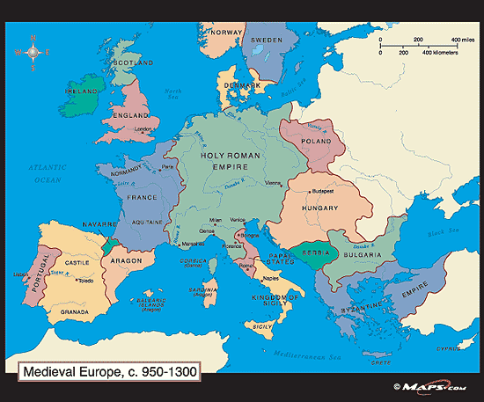
Barbarians Invade Rome! By Sharon Fabian
The Roman Empire, at its height, extended across much of Europe, but even then there were other groups of people who were not part of the Roman Empire living in Europe too. Many of these groups, called tribes, lived in the far north. Others lived in various parts of Europe not occupied by the Roman Empire. The barbarian tribes, as many of them were known, didn't like the idea of settling down and farming. They preferred a roaming, warlike lifestyle. Due to climate changes and other factors, many of the tribes began to migrate closer to the Roman Empire and sometimes even settle within the borders of the empire. This eventually led to conflicts between the tribes and the Romans. The Romans were used to being victorious in their clashes with various tribes, but this didn't happen every time.
In the late 300's AD, one tribe, the Visigoths, was being threatened by another tribe, the Huns. The Huns pushed the Visigoths further into Roman territory. This brought the Visigoths into more conflicts with the Romans. Eventually, it led to a big battle at Adrianople. This battle, in 376 AD, showed that the invaders had the strength to defeat Roman soldiers.
In 395 AD, Visigoth troops, led by Alaric I, invaded Italy and Greece. By the year 410, they attacked the city of Rome itself. There they killed Roman citizens, laid waste to buildings, and robbed the city. Meanwhile, the Huns were threatening Rome. The Huns were especially feared. The Huns crossed the Danube River and attacked Rome. They attacked Greece and Italy too. The Romans fought back and forced the Huns to retreat.
But the power of Rome was weakening. By the late 400's, Rome was no longer the mighty power that it had once been. In 476, the Hun leader, Odoacer, seized power in the western half of Rome and declared himself King of Italy.
The Roman Empire in the east continued on, but Roman rule in the west had come to an end. Europe entered into an era of uncertainty. Rulers changed frequently, as one leader attacked and defeated another. Invasions, attacks, and feuds were commonplace. It was the beginning of the Middle Ages.
Today, when we hear of Huns, we picture wild-eyed, long-haired, screaming invaders. The Goths also achieved a bad reputation. Maybe it was their scary look too. Maybe it was that the Roman Empire was the good guy, and someone had to be the bad guy. However it happened, the word gothic developed bad connotations. That's why, later on, some of the scarier elements of the Middle Ages became known as gothic. Dark, spooky castles were called gothic. Stories set in dark, spooky castles, like Dracula, were called gothic too.
The early part of the Middle Ages is often portrayed as the time when the Roman Empire collapsed and barbarian attacks were an everyday event. It has been called the Dark Ages.

Lords and Ladies By Sharon Fabian
At the beginning of the Middle Ages, Europe wasn't divided into countries as it is today. Smaller areas were each controlled by the leader of the tribe that had conquered the area. Eventually, some tribal leaders became more powerful than others, and the land that they controlled became larger and larger. When their land became very large, it became known as a kingdom, and the tribal leader became known as the king.
It was too difficult for the king to oversee everything that went on in his kingdom. He needed help. So he subdivided his land into smaller parcels and named a ruler for each part. These rulers, who were next in charge after the king, were known as lords, and their wives were known as ladies.
This system of sharing the power worked out well for the lords and also for the king. The lords gained a large piece of land, known as a fief, and the power to rule it. The king, in return, received a pledge of loyalty from his lords. This method of ruling the land and its people became known as the feudal system.
Under the feudal system, every lord pledged loyalty, or homage, to the king. He agreed to always support the king; he agreed to provide troops of knights ready to fight when needed; and he promised to do a good job of governing his part of the kingdom.
These pledges put a lot of responsibility on the shoulders of the lords. Having a large group of knights ready to fight at all times was a big job. The knights had to be trained, and they had to stay in practice. Their horses and equipment had to be kept ready.
The lord was in charge of overseeing all of these activities. Governing his estate was also a big job. Many peasants worked on the land. Many more worked in the shops and in the lord's castle. The lord was the manager of it all. He had to make sure that everything got done and that all of the people were taken care of. Sometimes problems arose on the estate. Then, the lord acted as a judge, holding court to settle the disputes. When the king called, the lord had to drop everything else and go to serve his king. When this happened, his wife, the lady of the castle, stepped in to manage the estate. She governed while the lord was away.
The lady of the castle had other duties too. She cared for her children and taught them while they were very young. Sometimes she oversaw the care and education of children from other noble families who were sent to stay on her estate. She entertained guests when they came to stay at the castle. She also was in charge of the household at all times, managing the kitchen, the meals, and the family accounts. Some ladies were even called on to lead their subjects in defending the castle if it was attacked while the lord was away.
The children of the lord and the lady had a much different life than children today. Often, they were sent away to another castle to be educated. Children were not expected to stay at home and be spoiled after the first few years of their life. They had to be educated and learn to deal with the world early on, because childhood lasted only a short time in medieval society. Many children were already engaged to be married before their teenage years. Most were married by the age of twelve to fourteen. Once they were married, it was time to take on adult responsibilities. Since the fiefs were passed down from fathers to sons, the boys would one day soon be rulers of their own land. The girls would marry the sons of other nobles and become the ladies of their own castles. The feudal system lasted throughout the Middle Ages. Under this system, the peasants could feel a little bit safer within the walls of their lord's castle, and the king could feel a little bit safer too with his lords and knights always at the ready. In an uncertain time like the Middle Ages, the feudal system provided some welcome security.

Objective 1 Homework Assignment
Directions: Read the articles “Barbarians Invade Rome” and “Lords and Ladies.” Then answer the questions below in complete sentences.

- What groups of people invaded Rome?

- What was Europe like after the fall of the Roman Empire?

- Why did kings give some of their land to lords?

- In feudalism, what did lords owe their kings?

- What were the responsibilities of lords?

- What were the responsibilities of ladies?

- Based on what you know so far, would you have wanted to live in the Dark Ages? Why or why not?

